Programming Fundamentals Lab 08
Rana Muhammad Hussain
25K-0141
Task 3 SS:
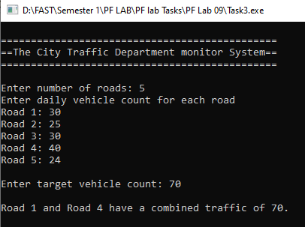
Task 4 SS:
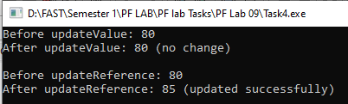
Task 5 SS:
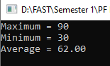
Task 6 SS:
